import java.io.*;
import java.math.*;
import java.security.*;
import java.text.*;
import java.util.*;
import java.util.concurrent.*;
import java.util.regex.*;
class Result {
public static String findDay(int month, int day, int year) {
Calendar calendar = Calendar.getInstance();
calendar.set(year, month - 1, day);
String[] days = {
"SUNDAY", "MONDAY", "TUESDAY",
"WEDNESDAY", "THURSDAY", "FRIDAY", "SATURDAY"
};
return days[calendar.get(Calendar.DAY_OF_WEEK) - 1];
}
}
public class Solution {
public static void main(String[] args) throws IOException {
BufferedReader bufferedReader = new BufferedReader(new InputStreamReader(System.in));
BufferedWriter bufferedWriter = new BufferedWriter(new FileWriter(System.getenv("OUTPUT_PATH")));
String[] firstMultipleInput = bufferedReader.readLine().replaceAll("\\s+$", "").split(" ");
int month = Integer.parseInt(firstMultipleInput[0]);
int day = Integer.parseInt(firstMultipleInput[1]);
int year = Integer.parseInt(firstMultipleInput[2]);
String res = Result.findDay(month, day, year)
bufferedWriter.write(res);
bufferedWriter.newLine();
bufferedReader.close();
bufferedWriter.close();
}
}
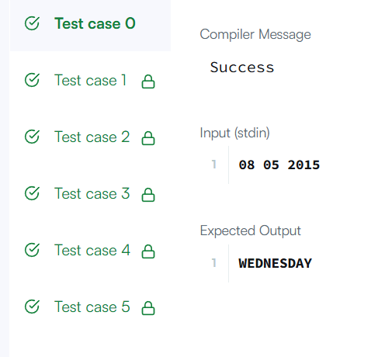
Task 2:
class Solution {
public int daysBetweenDates(String date1, String date2) {
int y1 = Integer.parseInt(date1.substring(0, 4));
int m1 = Integer.parseInt(date1.substring(5, 7));
int d1 = Integer.parseInt(date1.substring(8, 10));
int y2 = Integer.parseInt(date2.substring(0, 4));
int m2 = Integer.parseInt(date2.substring(5, 7));
int d2 = Integer.parseInt(date2.substring(8, 10));
return Math.abs(toDays(y1, m1, d1) - toDays(y2, m2, d2));
}
private int toDays(int year, int month, int day) {
int[] days = {31, 28, 31, 30, 31, 30, 31, 31, 30, 31, 30, 31};
int total = 0;
for (int y = 1971; y < year; y++) {
total += isLeap(y) ? 366 : 365;
}

for (int m = 1; m < month; m++) {
total += days[m - 1];
if (m == 2 && isLeap(year)) {
total++;
}
}
total += day;
return total;
}
private boolean isLeap(int year) {
return (year % 400 == 0) ||
(year % 4 == 0 && year % 100 != 0);
}
}
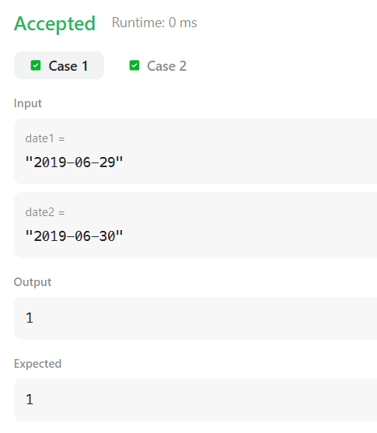
Task 3:
class Solution {
public int dayOfYear(String date) {
int year = Integer.parseInt(date.substring(0, 4));
int month = Integer.parseInt(date.substring(5, 7));
int day = Integer.parseInt(date.substring(8, 10));

int[] days = {31, 28, 31, 30, 31, 30, 31, 31, 30, 31, 30, 31};
int result = day;
for (int i = 0; i < month - 1; i++) {
result += days[i];
}
if (month > 2 && isLeap(year)) {
result++;
}
return result;
}
private boolean isLeap(int year) {
return year % 400 == 0 ||
(year % 4 == 0 && year % 100 != 0);
}
}
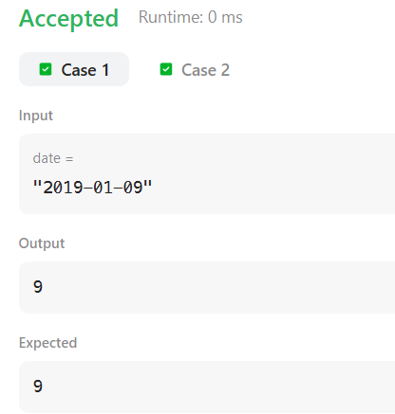
Task 4:
class Solution {
public String dayOfTheWeek(int day, int month, int year) {
String[] days = {"Sunday", "Monday", "Tuesday", "Wednesday",
"Thursday", "Friday", "Saturday"};
int[] monthDays = {31, 28, 31, 30, 31, 30,
31, 31, 30, 31, 30, 31};
int totalDays = 0;
for (int y = 1971; y < year; y++) {
if ((y % 4 == 0 && y % 100 != 0) || y % 400 == 0) {
totalDays += 366;
} else {
totalDays += 365;
}
}
if ((year % 4 == 0 && year % 100 != 0) || year % 400 == 0) {
monthDays[1] = 29;
}
for (int m = 0; m < month - 1; m++) {
totalDays += monthDays[m];
}
totalDays += day - 1;
int dayIndex = (totalDays + 5) % 7;
return days[dayIndex];
}
}
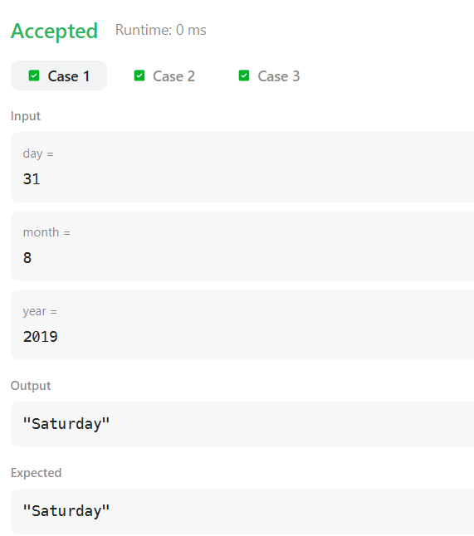
Task 5:
import java.util.ArrayList;
import java.util.List;
import java.util.Scanner;
class Student {
private int id;
private String name;
private double cgpa;
public Student(int id, String name, double cgpa) {
this.id = id;
this.name = name;
this.cgpa = cgpa;
}
public int getID() {
return id;
}
public String getName() {
return name;
}
public double getCGPA() {
return cgpa;
}
}
class Priorities {
public List<Student> getStudents(List<String> events) {
List<Student> queue = new ArrayList<>();

for (String event : events) {
String[] parts = event.split(" ");
if (parts[0].equals("ENTER")) {
Student s = new Student(
Integer.parseInt(parts[3]),
parts[1],
Double.parseDouble(parts[2])
);
queue.add(s);
} else {
if (!queue.isEmpty()) {
Student highest = queue.get(0);
int index = 0;
for (int i = 1; i < queue.size(); i++) {
Student current = queue.get(i);
if (current.getCGPA() > highest.getCGPA()
|| (current.getCGPA() == highest.getCGPA()
&& current.getName().compareTo(highest.getName()) < 0)
|| (current.getCGPA() == highest.getCGPA()
&& current.getName().equals(highest.getName())
&& current.getID() < highest.getID())) {
highest = current;
index = i;
}
}

queue.remove(index);
}
}
}
// Sort students by priority
for (int i = 0; i < queue.size(); i++) {
for (int j = i + 1; j < queue.size(); j++) {
Student a = queue.get(i);
Student b = queue.get(j);
if (b.getCGPA() > a.getCGPA()
|| (b.getCGPA() == a.getCGPA()
&& b.getName().compareTo(a.getName()) < 0)
|| (b.getCGPA() == a.getCGPA()
&& b.getName().equals(a.getName())
&& b.getID() < a.getID())) {
queue.set(i, b);
queue.set(j, a);
}
}
}
return queue;
}
}
public class Solution {
private final static Scanner scan = new Scanner(System.in);
private final static Priorities priorities = new Priorities();
public static void main(String[] args) {
int totalEvents = Integer.parseInt(scan.nextLine());
List<String> events = new ArrayList<>();
while (totalEvents-- != 0) {
String event = scan.nextLine();
events.add(event);
}
List<Student> students = priorities.getStudents(event)
if (students.isEmpty()) {
System.out.println("EMPTY");
} else {
for (Student st: students) {
System.out.println(st.getName());
}
}
}
}
Output:
Compiler Message
Success
Input (stdin)
- 12
- ENTER John 3.75 50
- ENTER Mark 3.8 24
- ENTER Shafaet 3.7 35
- SERVED
- SERVED
- ENTER Samiha 3.85 36
- SERVED
- ENTER Ashley 3.9 42
- ENTER Maria 3.6 46
- ENTER Anik 3.95 49
- ENTER Dan 3.95 50
- SERVED
Expected Output
- Dan
- Ashley
- Shafaet
- Maria
Task 6:
import java.util.*;
public class Solution {
public static void main(String[] args) {
Scanner sc = new Scanner(System.in);

int n = sc.nextInt();
ArrayList<ArrayList<Integer>> list = new ArrayList<>();
for (int i = 0; i < n; i++) {
int d = sc.nextInt();
ArrayList<Integer> arr = new ArrayList<>();
for (int j = 0; j < d; j++) {
arr.add(sc.nextInt());
}
list.add(arr);
}
int q = sc.nextInt();
for (int i = 0; i < q; i++) {
int x = sc.nextInt();
int y = sc.nextInt();
if (x >= 1 && x <= n && y >= 1 && y <= list.get(x - 1).size()) {
System.out.println(list.get(x - 1).get(y - 1));
} else {
System.out.println("ERROR!");
}
}
sc.close();
}
}
Input (stdin)
- 5
- 5 41 77 74 22 44
- 1 12
- 4 37 34 36 52
- 0
- 3 20 22 33
- 5
- 1 3
- 3 4
- 3 1
- 4 3
- 5 5
Your Output (stdout)
- 74
- 52
- 37
- ERROR!
- ERROR!
Expected Output
- 74
- 52
- 37
- ERROR!
- ERROR!
task 7:
class Solution {
public String largestNumber(int[] nums) {
String[] arr = new String[nums.length];
for (int i = 0; i < nums.length; i++) {
arr[i] = String.valueOf(nums[i]);
}
java.util.Arrays.sort(arr, (a, b) -> (b + a).compareTo(a + b));
if (arr[0].equals("0")) {
return "0";
}
StringBuilder result = new StringBuilder();
for (String s : arr) {
result.append(s);
}
return result.toString();
}
}
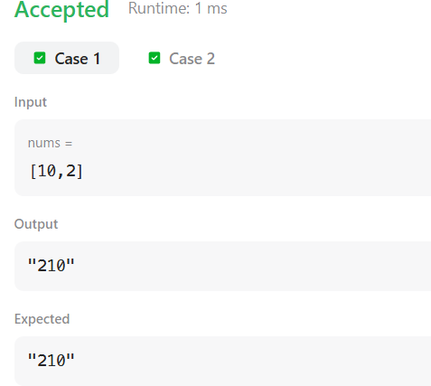
Task 8:
import java.util.*;
class Checker implements java.util.Comparator<Player> {
public int compare(Player a, Player b) {
if (a.score != b.score) {
return Integer.compare(b.score, a.score);
}
return a.name.compareTo(b.name);
}
}
class Player{
String name;
int score;
Player(String name, int score){
this.name = name;
this.score = score;
}
}
class Solution {
public static void main(String[] args) {
Scanner scan = new Scanner(System.in);
int n = scan.nextInt();
Player[] player = new Player[n];
Checker checker = new Checker();
for(int i = 0; i < n; i++){
player[i] = new Player(scan.next(), scan.nextInt());
}
scan.close();
Arrays.sort(player, checker);
for(int i = 0; i < player.length; i++){
System.out.printf("%s %s\n", player[i].name, player[i].score);
}
}
}
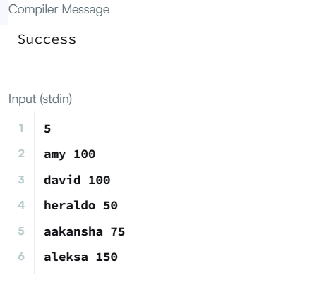
Task 9:
class Solution {
public String frequencySort(String s) {
int[] freq = new int[128];
for (char c : s.toCharArray()) {
freq[c]++;
}
// Store characters
Character[] chars = new Character[s.length()];
int index = 0;
for (char c = 0; c < 128; c++) {
if (freq[c] > 0) {
chars[index++] = c;
}
}
Arrays.sort(chars, 0, index, (a, b) -> freq[b] - freq[a]);
StringBuilder result = new StringBuilder();
for (int i = 0; i < index; i++) {
char c = chars[i];
for (int j = 0; j < freq[c]; j++) {
result.append(c);
}
}
return result.toString();
}
}
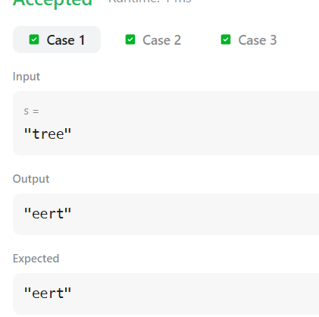
Task 10:
import java.util.*;
class Student {
int id;
String name;
double cgpa;
Student(int id, String name, double cgpa) {
this.id = id;
this.name = name;
this.cgpa = cgpa;
}
}
public class Solution {
public static void main(String[] args) {
Scanner sc = new Scanner(System.in);
int n = sc.nextInt();
ArrayList<Student> list = new ArrayList<>();
for (int i = 0; i < n; i++) {
int id = sc.nextInt();
String name = sc.next();
double cgpa = sc.nextDouble();
list.add(new Student(id, name, cgpa));
}
Collections.sort(list, (a, b) -> {
int cmp = Double.compare(b.cgpa, a.cgpa);
if (cmp != 0) {
return cmp;
}
cmp = a.name.compareTo(b.name);
if (cmp != 0) {
return cmp;
}
return Integer.compare(a.id, b.id);
});
for (Student s : list) {
System.out.println(s.name);
}
sc.close();
}
}
